NAME: SYED MUHAMMAD SHAHEER ALI SHAH

CLASS: BCS-2C

ROLL NO: FA20-BCS-079

LAB TASK 4 MAY 2021

1. Write A program to declare 5 pointers and print its addresses.

Answer:

#include<stdio.h>

int main()

{

int \*ptr1=NULL,\*ptr2=NULL,\*ptr3=NULL,\*ptr4=NULL,\*ptr5=NULL;

printf("The address of 1st pointer is %p\n",&ptr1);

printf("The address of 2nd pointer is %p\n",&ptr2);

printf("The address of 3rd pointer is %p\n",&ptr3);

printf("The address of 4th pointer is %p\n",&ptr4);

printf("The address of 5th pointer is %p\n",&ptr5);

return 0;

}

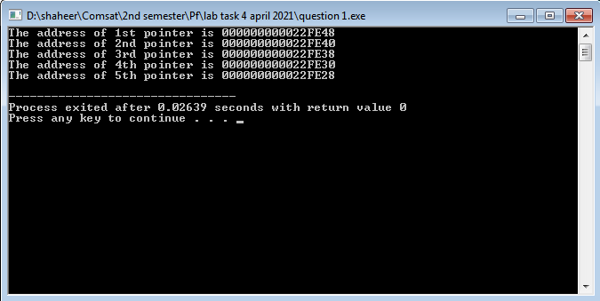

2. Write A program to Add address of two pointers.

Answer:

#include<stdio.h>

int main()

{

int \*ptr1=NULL,\*ptr2=NULL,\*ptr3=NULL;

int num1,num2;

num1=&ptr1;

num2=&ptr2;

ptr3=num1+num2;

printf("The address of pointer 1 is %p\n",&ptr1);

printf("The Address of pointer 2 is %p\n",&ptr2);

printf("The sum of these two pointer are %p",ptr3);

return 0;

}

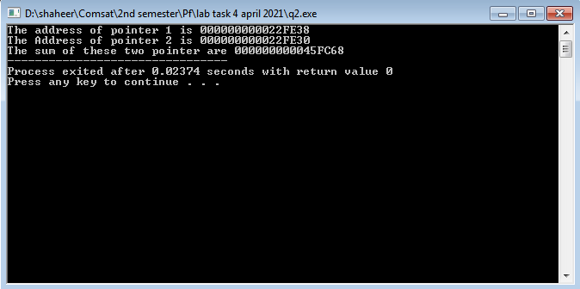

3. Write A program to point a pointer up to 5 levels and print them. Use variable int i = 3; and use 5 pointers to store its address, i.e. first pointer store the address of I variable, second point stores the address of first pointer, third pointer stores the address of second point and so on up to the 5th.

Answer:

#include<stdio.h>

int main()

{

int i=3;

int \*ptr1=NULL,\*\*ptr2=NULL,\*\*\*ptr3=NULL,\*\*\*\*ptr4=NULL,\*\*\*\*\*ptr5=NULL;

ptr1=&i;

ptr2=&ptr1;

ptr3=&ptr2;

ptr4=&ptr3;

ptr5=&ptr4;

printf("The address of variable i is %x and value store in pointer 1 is %x\n",&i,ptr1);

printf("The address of pointer 1 is %x and value store in pointer 2 is %x\n",&ptr1,ptr2);

printf("The address of pointer 2 is %x and value store in pointer 3 is %x\n",&ptr2,ptr3);

printf("The address of pointer 3 is %x and value store in pointer 4 is %x\n",&ptr3,ptr4);

printf("The address of pointer 4 is %x and value store in pointer 5 is %x\n\n",&ptr4,ptr5);

printf("referncing the variable i through pointer 1 is %d\n",\*ptr1);

printf("referncing the variable i through pointer 2 is %d\n",\*\*ptr2);

printf("referncing the variable i through pointer 3 is %d\n",\*\*\*ptr3);

printf("referncing the variable i through pointer 4 is %d\n",\*\*\*\*ptr4);

printf("referncing the variable i through pointer 5 is %d\n",\*\*\*\*\*ptr5);

return 0;

}

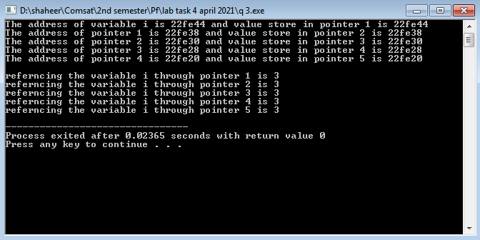

4. Write A program to implement basic mathematics (Add, Subtract, Multiply) by using functions and pointers.

Answer:

#include<stdio.h>

int check(int \*ptr1, int \*ptr2 , int \*ptrsum, int \*ptrsub , int \*ptrmulti)

{

\*ptrsum=\*ptr1 + \*ptr2;

\*ptrsub=\*ptr1 - \*ptr2;

\*ptrmulti=\*ptr1 \* \*ptr2;

}

int main()

{

int num1,num2,sum,sub,multi;

printf("Enter two number to find their sum,substraction and multipication\n");

scanf("%d %d",&num1,&num2);

check(&num1,&num2,&sum,&sub,&multi);

printf("Sum = %d\n",sum);

printf("Substraction = %d\n",sub);

printf("Multiplication = %d\n",multi);

return 0;

}

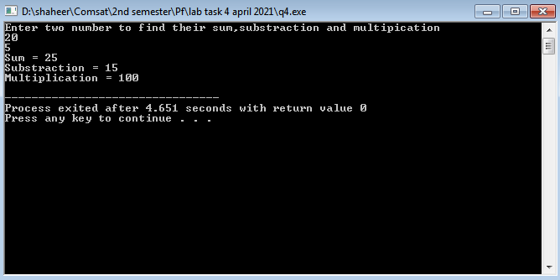

5.Write A program to declare a pointer of 1D Array and print its addresses.

Answer:

#include<stdio.h>

int main()

{

int aray[10]={0},i;

int \*ptr;

for(i=0;i<9;i++)

{

ptr=&aray[i];

printf("The address of aray[%d] is %p\n",i,ptr);

}

return 0;

}

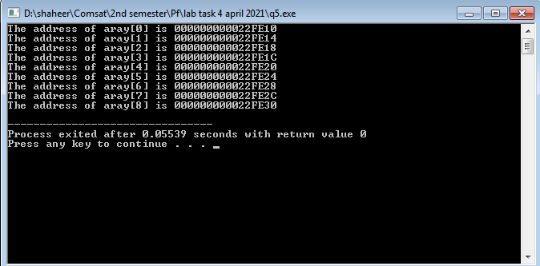

6. Write A program to take information of Student (name, age, department, cgpa) and print its addresses along with its values. Ans:

#include<stdio.h>

int main()

{

int age,\*ptrage;

char department[5],\*ptrdep;

float cgpa,\*ptrgpa;

printf("Enter age of student\n");

scanf("%d",&age);

printf("Enter department of student\n");

scanf("%s",department);

printf("Enter Cgpa of student\n");

scanf("%f",&cgpa);

ptrage=&age;

ptrdep=department;

ptrgpa=&cgpa;

printf("The adress of age is %p and age is %d\n",ptrage,\*ptrage);

printf("The adress of department is %p and department is %c%c\n",ptrdep,\*ptrdep,\*(ptrdep+1));

printf("The adress of cgpa is %p and Cgpa is %.2f\n",ptrgpa,\*ptrgpa);

return 0;

}

